Test Paper 2

Name – Rohit Agarwal

TR3

1. Write the command to count the number of lines in a file /var/log/messages containing the string "error".

Ans.

grep -c -e "error" /var/log/messages



1. How can you use grep to display all lines in a file /var/log/dnf.log that do not contain the word DEBUG?

Ans.

grep -v "DEBUG" /var/log/dnf.log 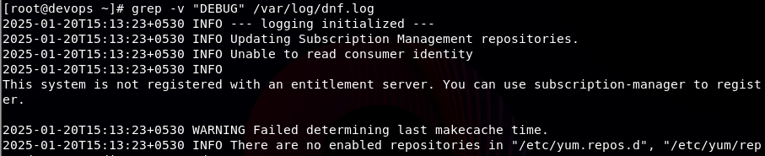

1. Explain the purpose of the following command and describe what it does: command > /dev/null 2>&1

Ans.

“ > /dev/nul 2>&1 “

Is same as the “ &>”

This redirection write both the output and error of a command to a single file

1. How can you redirect both the standard output and standard error of a command to the diffrent file? Write the appropriate command for redirecting the output of ls /usr to a file named errors.log.

Ans.

You can redirect the output of a command and error by using the redirections

“ > “ can be used to redirect the output of the command to a file

“ 2> “ can be used to redirect the error of the command to a file

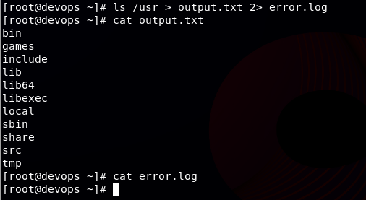

1. Create a file named sed.txt enter the content linux (twice), redhat, ubuntu, windows, Mac. Write the command to find the word redhat and replace that word to centos. And write command to delete the word linux . (Hint – Use sed command)

Ans.

sed -i ‘s/redhat/centos/’ sed.txt

sed -i ‘/linux/d’ sed.txt

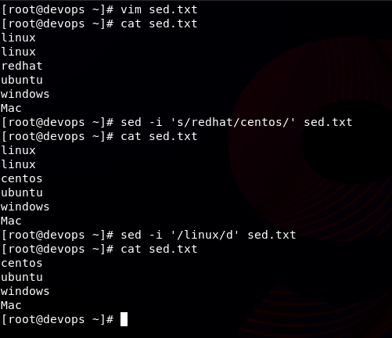

1. You have a file users.txt containing 1,000 usernames, one on each line. Write a pipeline command to display lines 101 to 110 from the file.

Ans.

head -110 users.txt | tail -10

1. How can you copy three files: file1.txt, file2.txt, and file3.txt into a directory named backup?

Ans.

cp file1.txt ./backup/

cp file2.txt ./backup/

cp file3.txt ./backup/

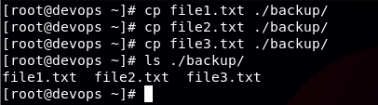

1. Create a collaborative directory /udaipur/techno/njr and now create 20 files as file1.txt to file20.txt in a single command, location must be /udaipur/techno/njr. ( hint use command separator )

Ans.

mkdir -p /udaipur/techno/njr && cd /udaipur/techno/njr && touch file{1..20}.txt 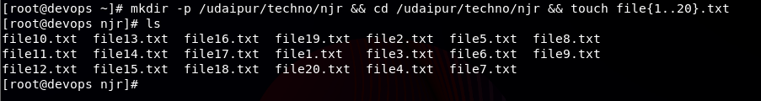

1. Difference between || su || & || su - || command.

Ans.

The difference between “ su “ and “ su – “ is that

“ su “ -> switches the user without changing the environment and using the same environment

“ su – “ -> switches the user to the new environment

1. Explain each field of /etc/passwd and /etc/shadow file.

Ans.

/etc/passwd file

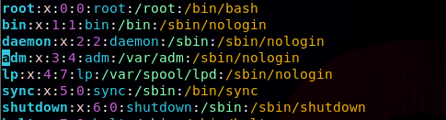

root:x:0:0:root:/root:/bin/bash

username : x : UID : GID : Group : Home Directory : Shell Permission

in the previous versions, the x had password but in new versions it has been moved to a seprate file so this field remains x

/etc/shadow: Stores password information and security-related details like password expiration and account expiry.

1. When a new user is created on the system, the default password aging policy should ensure that the user's password expires after 90 days.

Ans.

Go to the file named /etc/login.defs

`vim/etc/login.defs`

And change the value of the PASS_MAX_DAYS to 90 to set it default to make user change password every 90 days

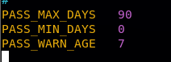

1. Difference between superuser, systemuser & regular user.

Ans.

Superuser – root

Has the power to do every thing and run every command in the system. They are like the owner of the system and has full control

Systemuser –

Are user whose UID is between range 1 to 999 and cannot log in to the shell

They are used by programs to execute and do certain tasks

Regular User –

They are normal users and their UID ranges from 1000 to 60000. They can login into the shell and will login to there home directory

1. Create a group named sysadmin and add harry and raj in the group. They should not be removed from existing groups. Change the Primary group of user prem as sysadmin.

Ans.



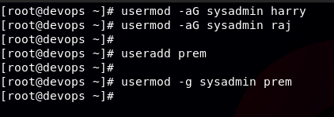

Added user harry, prem, raj

Added sysadmin as group

Added sysadmin as secondary group to harry and raj

Added sysadmin as primary group to prem

1. Configure password policies of harry user such that its Account get expired on 23 05-2026.

Ans.

chage -E 23-05-2026 harry



1. If I delete a user, Does it's home directory and mail file gets deleted? If not then what is the command to delete the home directory and mail file of user along with the user.

Ans.

userdel -r consultants1

